**User Guide**

1. **Normal site:**

Home page: Show brief description of the institute and that of the courses offered, new course details, etc.

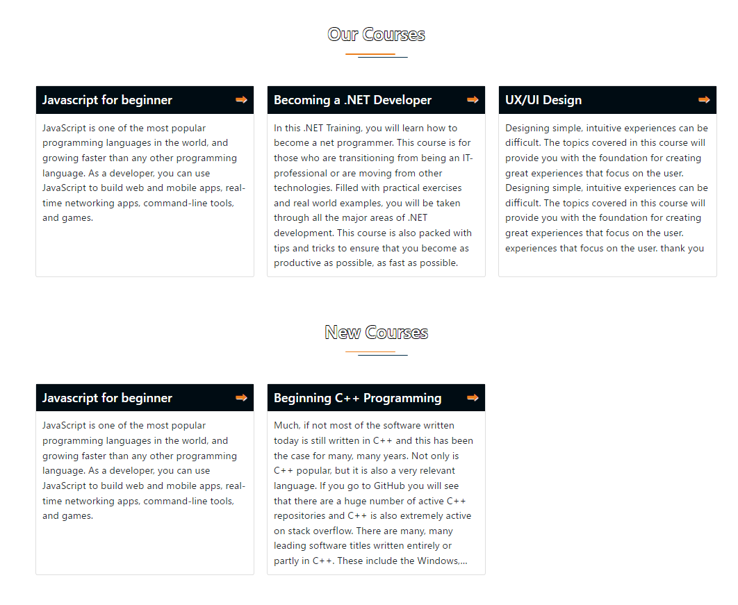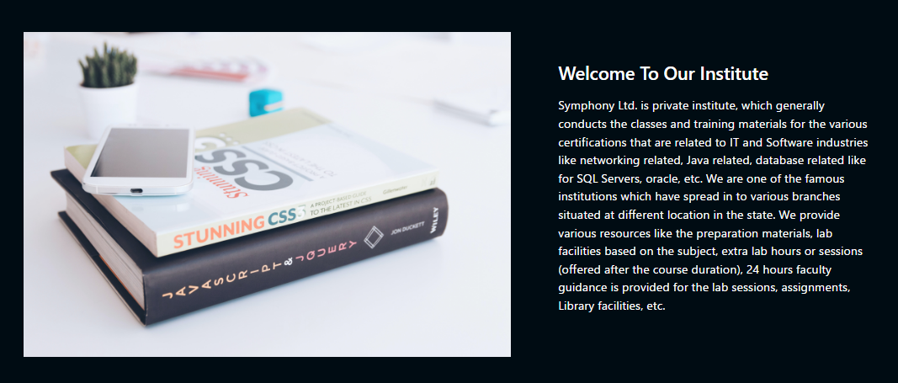

About Us: Show information about the institute

Course Details: Show list of the various courses offered and topic covered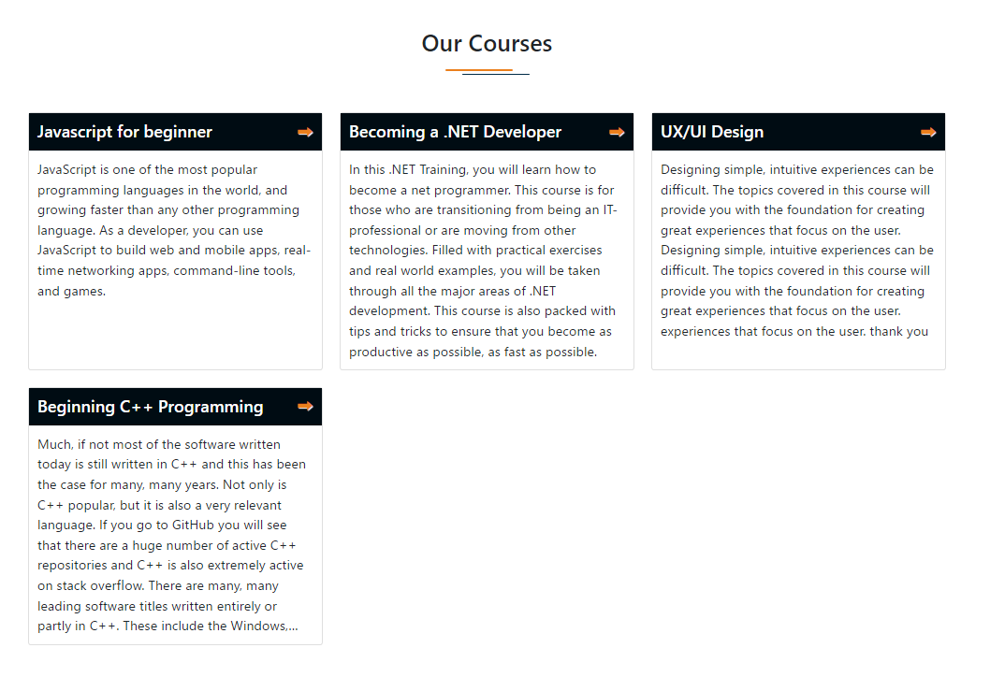

Entrance Examination: Show details of the upcoming examinations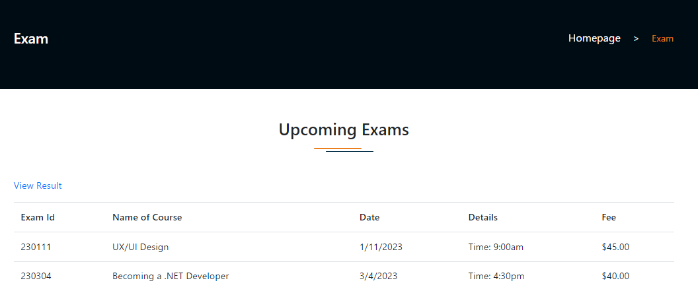

Entrance Examination Result: Enter roll number and the result will be displayed along with the course the student is segregated into, the fees of the course, and the last date for payment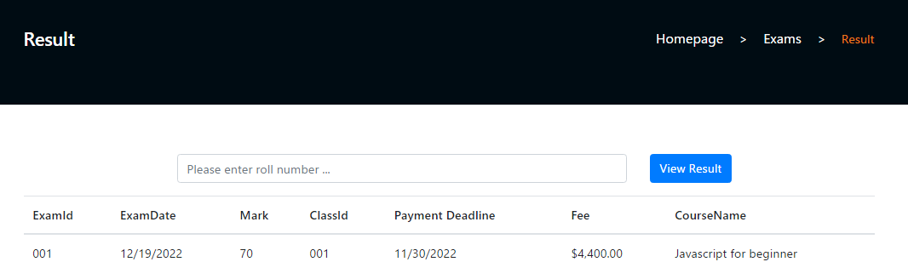

FAQ’s: Frequently asked questions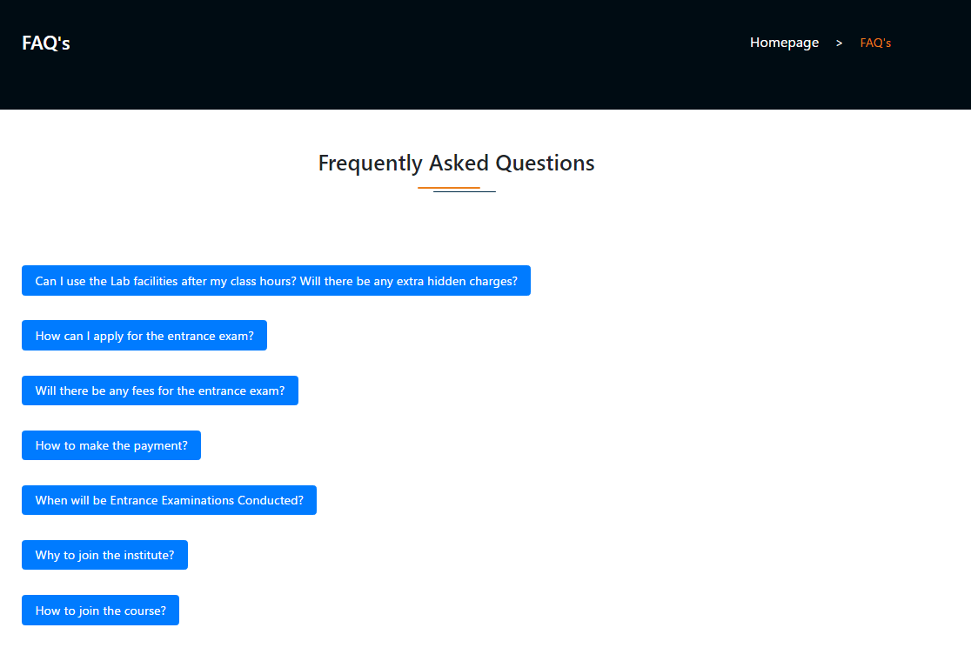

Contact Us: show list of the various centres located at different places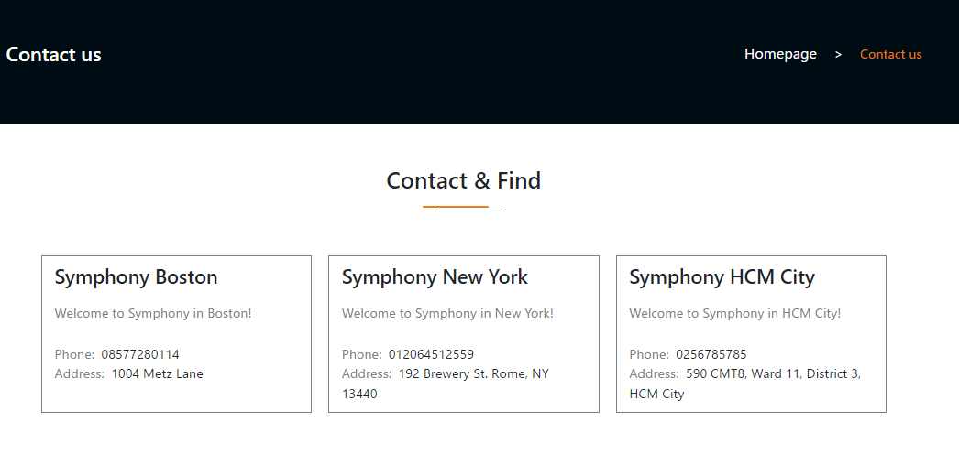

1. **Admin site:**

Login is required

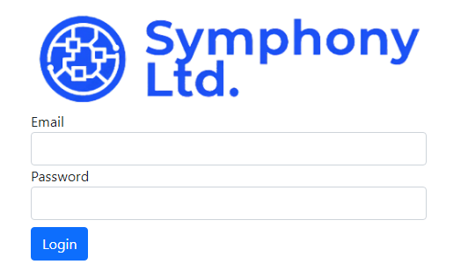

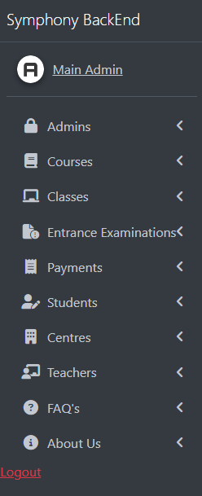

Admin Management: Add/Edit/Delete Admin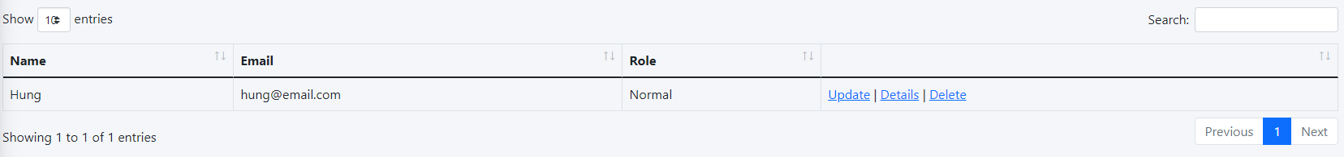

Course Management: Add/Edit/Delete course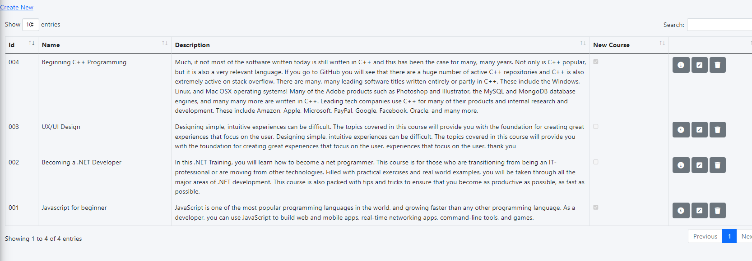

Exam Management: Add/Edit/Delete exam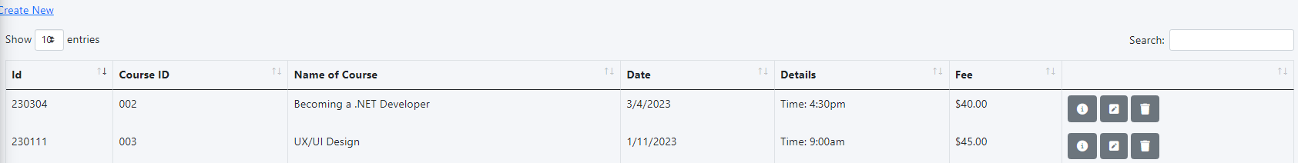

Student Management: Add/Edit student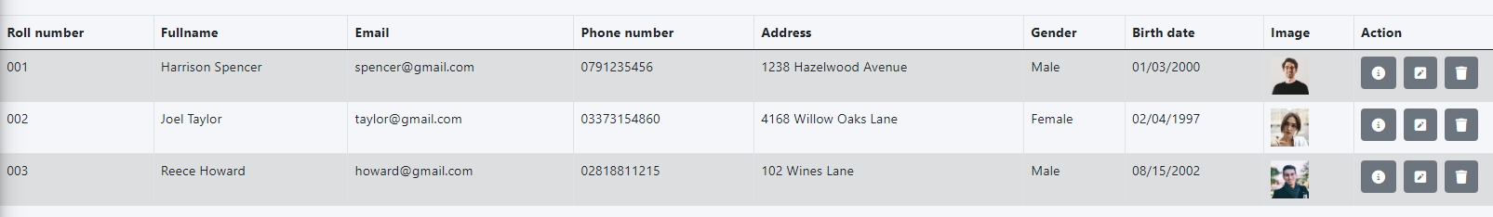

About Us Management: Add and edit information about the institute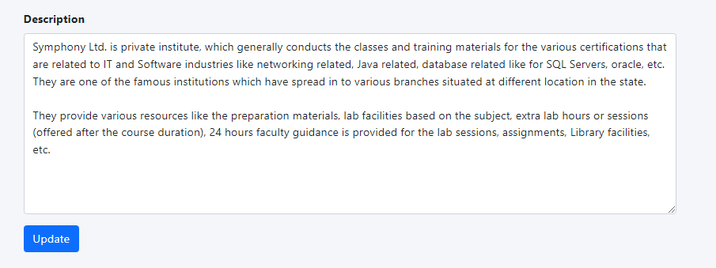

FAQ Management: Add/Edit/Delete the FAQ’s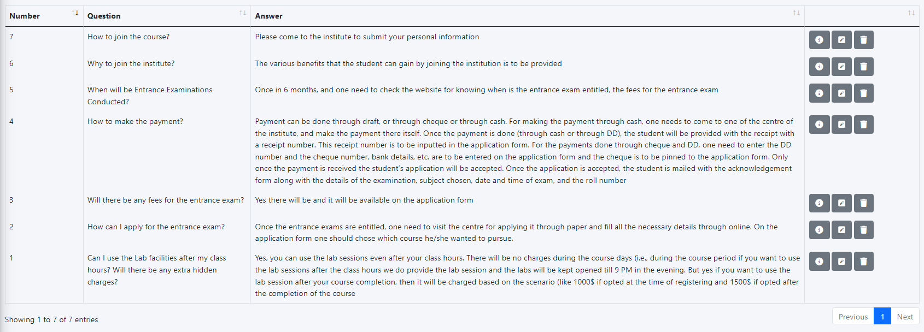

Centre Management (Contact Us) 